**AI IN WEB3: HOW AI MANIFESTS IN THE WORLD OF WEB3**

Centralization has long been the norm for AI-based solutions, but as we delve into the decentralized world of Web3, the question arises: How can AI adapt to and thrive in this new landscape, shedding its centralization tendencies?

1. **What is Web3?**

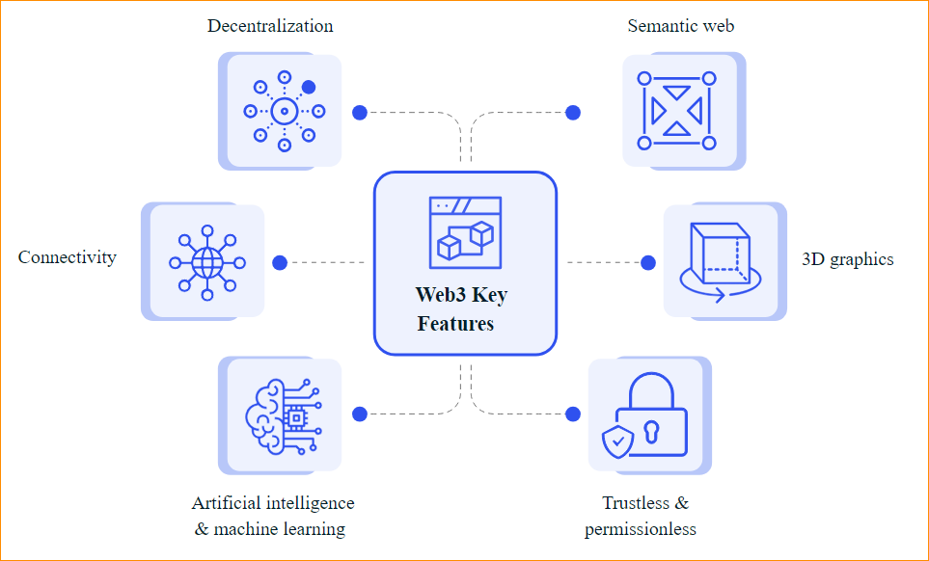

Web3 is the **next-generation internet that envisions a decentralized, secure, and user-centric digital ecosystem**. It involves sharing power and benefits through decentralization.

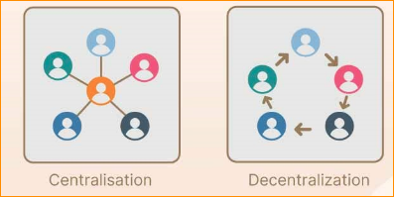

***Decentralization***

* Decentralization is a fundamental tenet of Web3
* Web2 uses HTTP to locate information, which is done using unique web addresses.
* Web3, by virtue of being blockchain-based, would allow information to be stored in multiple locations across a network.
* Web3 will allow users to sell the data generated from disparate computing resources such as mobile phones, desktops and appliances.

***Permission less and trustless:***

* Web3 is based on open-source software and is decentralized. Web3 apps that run on blockchains are called dApps.

***Artificial intelligence (AI) and machine learning:***

* Web3 will use technologies based on Semantic Web concepts and natural language processing to enable computers to understand information like humans.
* Web3 will also utilize machine learning.
* This branch of artificial intelligence uses data and algorithms to mimic human learning, slowly improving its accuracy. These capabilities will allow computers to produce more relevant and faster results in many areas.

***Connectivity:***

* Information and content are more connected with Web3 and are accessible by multiple applications.
* there is an increase in the number of devices that can connect to the internet. The Internet of Things also has an important role to play here.

1. **What is AI?**

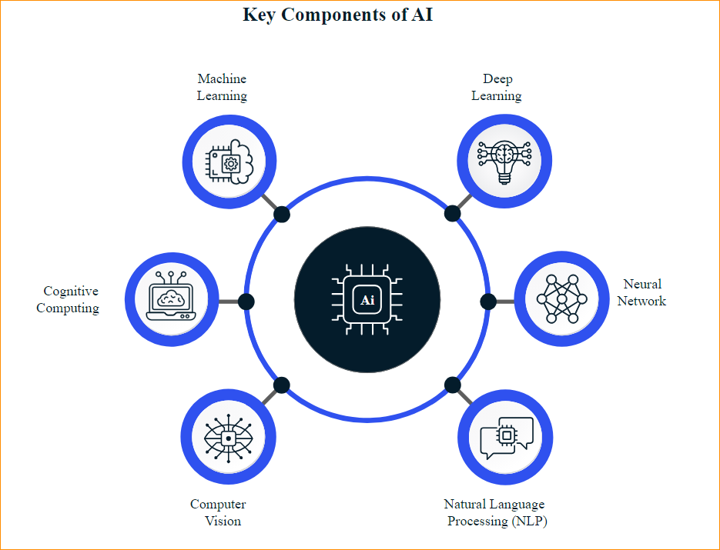

* Artificial intelligence (AI) is the simulation of human intelligence by computer systems
* Examples - expert systems, natural language processing (NLP), speech recognition and computer vision
* AI is built on specialized hardware and software that can be used to write and train machine learning algorithms.
* AI systems generally work by ingestion of large amounts of labeled data.
* They then analyze the data for patterns and correlations and use these patterns to predict future states.

Two types of artificial intelligence

**Strong AI -**

Systems with strong artificial intelligence can perform human-like tasks. These systems are more complicated and complex. These systems are programmed to solve problems without human intervention. Examples of strong AI are self-driving cars and hospital operating rooms.

**Weak AI -**

A weak AI system has been designed to do a particular job. Video games and personal assistants like Siri and Amazon’s Alexa are examples of weak AI systems. The assistants answer your questions by asking you questions.

1. **How AI in Web3 makes layers of Web3 intelligence?**

ML will spread to different layers of the Web3 stack. Three key Web3 layers can provide ML-driven insights.

1. **Intelligent blockchains**

* Current blockchain platforms focus on developing key distributed computing components that allow for the decentralized processing of financial transactions. These key building blocks include consensus mechanisms, mempool structures, and oracles.
* These key building blocks include consensus mechanisms, mempool structures, and oracles.
* The next generation of layer 1 and layer 2 blockchains (companion and base) will incorporate ML-driven capabilities, just as the core components of traditional software infrastructures like storage and networking are becoming more intelligent.
* To illustrate, a blockchain runtime can use ML prediction to make transactions in order to create scalable consensus protocols.
* I can add security to the blockchain, and AI applications can quickly mine data and predict behavior, detecting fraudulent behavior and stopping attacks.
* The blockchain will also benefit from AI as an AI protocol that might be able to predict transactions and create consensus protocols that scale easily.

1. Intelligent protocols

* Web3 stack can also integrate ML capabilities through the use of smart contracts and protocols.
* DeFi most prominently illustrates this trend. We are not far from seeing DeFi computerized market makers (AMMs) or lending protocols with more intelligent logic that is based on ML models.
* for example, imagine a lending protocol using an intelligent score to balance loans from different types of wallets.

1. Intelligent dApps

* Decentralized applications (dApps) are expected to be among the most popular Web3 solutions for rapidly adding ML-driven features. This trend is already evident in NFTs and will continue to grow.
* Next-generation NFTs will move from static images to artifacts with intelligent behavior. These NFTs may be able to adapt their behavior to the mood of the profile of their owners.

1. **Why AI in Web3?**
2. Shift from generalization to individualism

Big tech has used centralized AI models over the past decade to extract value from users and gain insights. In Web3, we are advancing the capabilities of AI to serve all people, not just the wealthy few. Every AI model is trained on the creator’s personal knowledge, passions, and experiences.

1. From users to owners

A handful of private companies control all the content generated and make a profit from it. Consequently, content creators often remain underpaid and neglected.

In Web3, creators fully control their data, AI models and digital assets. Few companies are helping to build platforms on blockchain, so creators have the sole access and power of their data to repurpose or share it as they wish.

1. From scarcity to utility

To ensure long-term sustainability, tokens are not enough to give users ownership or incentives. Tokens must be useful and provide real value to their users.

Your personal AI creates and unlocks new value from the content you create and the creativity and intellect you use to create it. Your personal AI unlocks new opportunities for collaborations and creates value for you and your community through access and participation enabled by social tokens.

1. From consumption to participation

Creators and their communities have their own platform, thanks to personal AIs and their own way of exchanging value with social tokens. We are creating a new architecture of collaborative networks that shifts power from platforms to people and transforms the relationship between value consumption and value creation.

1. Subscriptions and investments

Creators have always hoped to build a large subscriber base over many years and then, hopefully, eventually monetize the subscriber base. The reality is that only a handful of creators earn a decent wage, and this situation is not good for either the creators or their subscribers.

I in Web3 is driving a new creator economy that allows communities to invest in creators they love as well as the personal AIs that add value to their lives. Creators now have the opportunity to build a sustainable business around their creativity, and the community can benefit from this success.

1. **Key Web3 areas where AI shows promise**

AI is playing a significant role in the evolution of Web3, contributing to the realization of a more decentralized, secure and user-centric Internet. By integrating AI capabilities into various areas of Web3, we can expect to witness increasingly intelligent, efficient and personalized digital experiences.

Some key areas where AI can have a significant impact in Web3 include:

1. Smart contracts

AI can enhance the functionality of smart contracts in Web3 by integrating advanced decision-making capabilities, enabling more intelligent and dynamic transactions on decentralized platforms built on blockchain technology. AI can analyze vast amounts of data, make informed decisions, and automate complex workflows, reducing human intervention and errors. AI can also optimize smart contracts by identifying inefficiencies or vulnerabilities in the contract's logic or execution, using techniques like reinforcement learning or genetic algorithms to improve performance, security, and reliability.

1. Decentralized Autonomous Organizations (DAOs)

Artificial intelligence (AI) can significantly improve the governance and decision-making processes within Decentralized Autonomous Organizations (DAOs). DAOs, governed by blockchain rules, can be streamlined by AI algorithms that analyze vast data to identify patterns and trends. This increases efficiency and transparency, fostering trust and accountability. AI can also enhance adaptability by enabling DAOs to respond more effectively to changing conditions or emerging challenges. It can also optimize resource allocation within DAOs by analyzing data on performance, needs, and priorities, maximizing the overall impact and effectiveness of DAOs. This integration of AI can significantly enhance DAOs' efficiency, transparency, and adaptability.

1. Decentralized AI

Decentralized AI is a method that integrates artificial intelligence with decentralized technologies like blockchain and distributed computing. It allows AI models to be trained and utilized in a distributed manner, enhancing privacy, security, and reducing reliance on centralized entities. This approach uses techniques like federated learning, where training occurs on individual devices or nodes, and enables complex computations on multiple devices or nodes. It also facilitates collaborative model development using cryptographic techniques and blockchain technology, providing trust and transparency. Decentralized AI also facilitates incentive mechanisms for data sharing, model training, and resource utilization, particularly beneficial for edge AI and IoT devices. This reduces reliance on centralized cloud infrastructure and enhances system resilience.

1. Personalization

Artificial intelligence (AI) can enhance personalization in Web3 by analyzing user data, tailoring content, and generating personalized recommendations. Machine learning techniques, such as collaborative filtering and content-based filtering, can generate recommendations based on user behavior and attributes. AI-driven personalization can extend to user interfaces, communication, and advertising, incorporating natural language processing and sentiment analysis. In advertising, AI can enable targeted campaigns by identifying relevant ads, resulting in effective advertising and better conversion rates. Overall, AI can create more engaging and personalized experiences for users.

1. Web3 applications

Natural language processing (NLP), a subfield of artificial intelligence, can significantly improve user interaction with decentralized applications. NLP facilitates seamless communication between users and applications, allowing them to interpret and respond to queries in natural language. It also helps Web3 applications understand the context and sentiment behind user-generated content, enhancing engagement and satisfaction. NLP can automate content generation, create relevant and engaging content, and analyze vast textual data to uncover insights and trends, ultimately promoting the development and optimization of Web3 applications and services.

1. Data analysis and insights

AI plays a vital role in data analysis and insights within the Web3 ecosystem, processing and analyzing vast amounts of data generated by decentralized platforms, applications, and services. Advanced AI techniques, such as machine learning, deep learning, and natural language processing, can uncover hidden patterns and trends, providing actionable insights for developers, users, and stakeholders. These insights can inform the development and optimization of Web3 applications and services, identifying bottlenecks, inefficiencies, and emerging trends. AI can also enhance security and trust by identifying potential vulnerabilities, threats, or malicious activities, fostering confidence among users and stakeholders.

1. Security and privacy

AI can significantly enhance security and privacy in the Web3 ecosystem by detecting and preventing cyber threats, developing secure authentication methods, and ensuring user data privacy through encryption and anonymization techniques. AI can monitor and analyze large amounts of data to identify potential vulnerabilities, malicious activities, and abnormal patterns, fostering trust among users and stakeholders. It can also develop secure multi-party computation protocols, allowing multiple parties to jointly perform computations on encrypted data without revealing underlying information. Additionally, AI can develop sophisticated data anonymization techniques like differential privacy, preserving individual privacy while enabling meaningful data analysis.

Reference - <https://www.leewayhertz.com/ai-in-web3/>